ABTMSE Software Design Specification (v2.3.0)

Tom Carruthers <t.carruthers@oceans.ubc.ca>
https://github.com/ICCAT/abft-mse/R_package

Developed for ICCAT GBYP 29/1/2018

Table of Contents
1. Introduction and System Overview 3
2. Design Considerations 4
2.1. ABTMSE Assumptions and Dependencies 4
2.2. General Constraints 4
2.3. Goals and Guidelines 4
3. Architectural Strategies 5
4. Policies and Tactics 6
5. Glossary 6
6. Bibliography 7

Introduction and System Overview

ABTMSE (Atlantic Bluefin Tuna – Management Strategy Evaluation) is an R package designed for simulation testing fishery management procedures to evaluate robustness, value of information and reveal management trade-offs. The package is coded in the R language (v3.4.0, R Development Core Team 2017) and developed in RStudio (v1.0143, 2017) with Rtools (v3.4) depending on R packages for computation (parallel, snowfall, methods), presentation (ggplot2) and documentation (roxygen2, knitr, rmarkdown, pkgdown).

ABTMSE depends on a multi-stock, spatial, seasonal, statistical catch at length stock assessment model called M3 (v1.9) that is fitted to fishery, survey and electronic tagging data. The ABTMSE framework reproduces the stock and fishery dynamics estimated by the M3 assessment model and then projects these into the future subject to management by user-specified management procedures (a mode of management, e.g. TAC setting by stock assessment model subject to a harvest control rule). Although more complex since it has spatial and seasonal dynamics, the M3 model and ABTMSE operating models follow the standard equations for age-structured population dynamics (e.g. Quinn and Deriso 1999, Chapter 8).

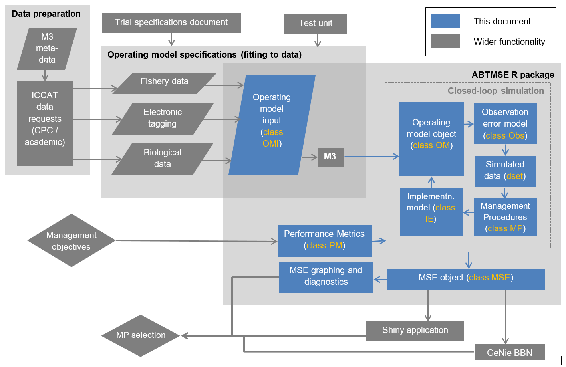

Figure 1. The ABT-MSE framework. ABTMSE R package components are highlighted in blue. Object classes are colored orange.
This document is intended as an overview of the ABT-MSE R package, its functionality, role in the wider MSE framework, configuration options, design brief and objectives.

Design Considerations

ABTMSE Assumptions and Dependencies

- Dependent on R packages: MASS, parallel, snowfall, methods, ggplot2, roxygen2, knitr, rmarkdown, pkgdown.
- I/O from M3 operating model
- Should run in Mac, Linux and Windows operating systems
- Intended for use by quantitative fisheries analysts
- The first priority is ease of customization by users

General Constraints

- Must be portable (available in a single transferable file preferably small enough to email)
- Should have an intuitive system for documentation
- Must allow for exactly reproducible results
- Must allow users to customize operating models, management procedures and performance metrics.
- Must be based on an established programming language / framework allowing other users to modify code.
- Should allow for customizable catch allocation and spatial definition of assessments/stocks

Goals and Guidelines

- Support the testing of alternative a management procedures
- Allow for evaluation of various stock and fishery assumptions (custom operating models).
- Support custom performance metrics
- Provide a wide range of options for visualizing and interpreting MSE outputs
- The package should allow for all 7 steps of MSE as described by Punt and Donovan (2007):

- qualitative specification and prioritization of the management objectives, as derived from legislation, legal decisions, and international standards and agreements;
- quantification of the qualitative management objectives in the form of performance measures;
- development and parameterization of a set of “operating models” that represent different plausible alternatives to the dynamics of the “true” resource and fishery being managed;
- identification of candidate management procedures, including monitoring strategies;
- simulation of the future use of each candidate management procedure, involving for each time-step during the projection period: (a) generation of assessment data; (b) determination of the management action (i.e. assessment and application of some HCR); and (c) evaluation of the biological implications of the management action by removing the catch from the population as represented in the operating model;
- summary of the performance of the candidate management procedures in terms of values for the performance measures; and
- selection of the management procedure that best meets the specified objectives.7):

Architectural Strategies

ABT MSE was coded as an R package because:

- R is now the de facto software development and analysis environment for scientists, which maximizes the accessibility of the ABT-MSE software for users.
- Through the CRAN repository, R includes numerous additional packages allowing for a high degree of flexibility in data organization, analysis and presentation. This additional functionality provides a wide scope for user-specified additions to the framework and maximizes the likelihood of incorporating new methods and management procedures.
- R includes a built-in system of documentation allows all functions, data and objects to be queried by users including examples of their intended use.
- R documentation can be efficiently produced using packages such as ‘roxygen2’ and online materials can be developed using packages such as ‘pkgdown’.
- R includes a range of developer tools that can help users access and interpret the latest versions of the package, for example by installing the current development version from the GitHub website.
- Automatic document generation using ‘rmarkdown’ and ‘knitr’ allow for standardized reporting of operating model fits to data etc.
- R supports the flexible definition of object (e.g. an observation error model) and function (e.g. a management procedure) classes minimizing coding errors, providing support for generic methods and reducing the duplication of code. This object-oriented approach also allows users to find and investigate suitable pre-specified objects that are needed for running the MSE.
- R packages are portable and can be distributed as a single compressed file.
- R is freely available and very actively maintained and updated.

The formatted inputs to the assessment model (class OMI), operating models (class OM), observation error models (class Obs), implementation error models (Imp) and the outputs of the MSEs (class MSE) were also designed as object classes. This allows users to rapidly build and store new MSE runs. Management procedures (class MP) and performance metrics (class PM) were designed as function classes so that generic analyses (MSEs) and generic performance plots could be developed.

Policies and Tactics

All functions, data and objects should be documented both in the package and online.

Documentation of functions should include worked examples.

All features of the R package should be demonstrated in an extensive user guide

MSE is computationally intensive. Where possible computation should take advantage of parallel processing and allow for compiled code (e.g. .cpp .dll code) to minimize computation time.

Future considerations

Through 2018 – 2019 MPs are to be developed for ABT by various stakeholders. During this development a central requirement of the R framework will be to adapt to feedback from users. A number of potential problems and solutions can be anticipated:

Problem: computing limitations – the framework was developed on high-level workstations that may not reflect computing resources of the typical user.
Solution: a version of the ABT-MSE R framework is in development that increases the speed of calculations using compiled c++ code and also uses smaller matrices that require much less system memory.

Problem: availability of simulated data – users may wish to test MPs based on data that are not currently simulated in the MSE
Solution: observation models are being developed for all types of tagging including conventional (spaghetti), electronic archival, PSAT and genetic tags.

Problem: although the ABT-MSE framework stores a multitude of data generated by the running of the MP in the MSE simulation, stakeholders may require additional performance metrics that rely on simulation quantities not monitored
Solution: continue to work with stakeholders and implement new simulation monitoring schemes as they are requested.

Glossary

ABT – Atlantic Bluefin Tuna
ADMB – Automatic Differentiation Model Builder
Assessment model – A fishery model that represents system dynamics and is used to support management decision making.
dset – a simulated data set
I/O – Input / Output
IE – Implementation Error model
M3 – Modifiable Multi-stock Model, an assessment and operating model for Atlantic Bluefin Tuna.
MCMC – Markov Chain Monte Carlo
MLE – Maximum Likelihood Estimate
MP – Management procedure (an algorithm that takes you from data to a management recommendation)
MSE – Management Strategy Evaluation (or an object storing MSE outputs)
Obs – Observation error model.
OM – An operating model or an object storing operating model specification
OMI – An operating model input file containing formatted data for the M3 assessment model.
Operating model – A simulation model that represents a plausible hypothesis regarding real system dynamics
PM – A performance metric function
R – R statistical environment
GitHub – An online repository for computer code

Bibliography

GBYP. 2014. ICCAT Atlantic wide research programme for Bluefin Tuna. Available online at: http://www.iccat.int/GBYP/en/index.htm [accessed October 2014]
ICCAT-GitHub. 2016. ICCAT MSE for Atlantic Bluefin. https://github.com/ICCAT/abft-mse.
Quinn, T.J., Deriso, R.B. 1999. Quantitative fish dynamics. Oxford University Press, New York.
R Development Core Team (2017), R: A Language and Environment for Statistical Computing. Vienna, Austria : the R Foundation for Statistical Computing. ISBN: 3-900051-07-0. Available online at http://www.R-project.org/.

